SOC

Startup on the cloud

SRS

Introduced By Team 20

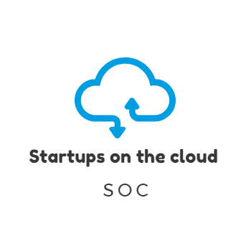

|  |  |  |  |  |
| --- | --- | --- | --- | --- |
| Version | Written By | Reviewed By | Approved By | Date |
| 0.X | Team 20 | Menna Mohamed | Dr.Sobh | 25/11/2018 |
| 1.X | Team 20 | Menna Mohamed | Dr.Sobh | 2/12/2018 |
| 2.X | Team 20 | Menna Mohamed | Dr.Sobh |  |

# Team Contribution

|  |  |
| --- | --- |
| Name | Role of each person |
| Rita Ehab &  Reham Ashraf | Domain requirements and system description |
| Menna Mohamad | Prototype and revision of SRS |
| Mona Mahmoud | System users |
| Menna Hussein | System interface |
| Salma Hesham | Non-functional requirements |
| Haidy Samir | System models |
| Nour Elhoda Ashraf | Functional requirements |
| Esraa Mohsen | System modules |

Contents

Team Contribution 2

1. Introduction 1

1.1. Executive Summary 1

1.2. Document Overview 1

1.3. Abbreviations and Terminologies 1

1.4. References 1

2. System Description 2

2.1. Introduction 2

Data flow diagram 2

2.2. Users 3

2.2.3. Developers 3

2.3. Modules 4

2.3.1. Storage 4

2.3.2. Data analysis 4

2.3.3. Indexing 4

2.3.4. Security 4

2.3.5. Cloud Service 4

2.3.6. Customer Area 5

2.3.7. Owners of Start Ups Area 5

2.3.9. General mobile Application 5

2.3.10. START UPS Authority area 5

2.3.11. System Administration Area 5

3. System Users 6

3.1. Developers 6

3.2. Owners 6

3.3. Customers 6

4. System Modules 7

4.1. Storage 7

Context Diagram 7

4.2. Data analysis 8

Context diagram 8

4.3. Indexing 8

4.4. Security 8

4.5. Cloud Service 9

4.6. Customer Area 9

Data flow diagram 10

4.7. Owners of startups area 11

Data flow diagram 11

4.8. Supervisors area 12

Data flow diagram 12

4.9. General mobile Application 13

4.10. START UPS Authority area 13

Data flow diagram 13

4.11. System Administration Area 14

5. System Functions 14

5.1. Create accounts 14

5.2. Give feedback 14

5.3. Startup page 15

5.4. Filter startups 15

5.5. Place of the day 15

5.6. Set promo codes 16

5.7. Loyalty membership 16

5.8. Give a feedback 16

6. System Models 17

Use Case Diagrams 17

Sequence Diagrams 20

7. Non-Functional Requirements 24

7.1. Security 24

7.2. Usability 24

7.3. Performance 24

7.4. Development 24

8. Domain Requirements 25

8.1. Market Requirements 25

9. System Interfaces 25

9.1. User Interfaces 25

9.2. Hardware interfaces 30

# Introduction

## Executive Summary

”Startups on the cloud” is a website which can be considered as the linkage between startups and their customers. It will be a very important tool for startups owners in order to market their projects. Startups on the cloud will also help whoever is looking for new nearby place (ex.: restaurant, café or co-working space) to find it easily.

## Document Overview

This document contains a description of our project. It describes and illustrates the diagrams of the system. It also illustrates the functions of the system. These functions are: the functional requirements, the nonfunctional requirements, and the domain requirements as well. Not only that, this document provides the system user which provides user role description in details.

## Abbreviations and Terminologies

|  |  |
| --- | --- |
| SOC | Startups on cloud |
| UP | User profile |
| OP | Owner profile |
|  |  |

## References

1. https://en.wikipedia.org/wiki/Software_requirements_specification 2- The SRS template’s doctor.

# System Description

## Introduction

Startup on the cloud website is an online meeting point between customers and startup owners where startup owners can provide their startup service showing their category of service (Co-working space, event and project planning, handmade jewelry, custom clothes, open days, startup café, entertainment place, keto foods, vegan food). And from the customer side he/she can search for the category of place they want to visit and have an access to the location and ratings and reviews and after their visit they can give feedbacks and pros and cons about the startups so others can see, and also see the clouds rating

### Data flow diagram

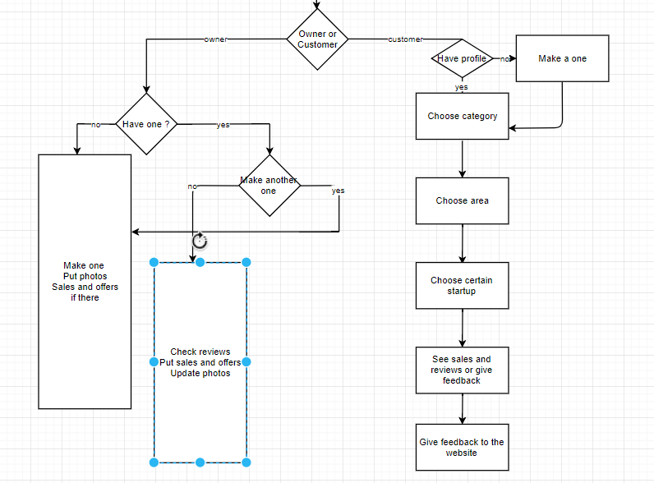

Context diagram

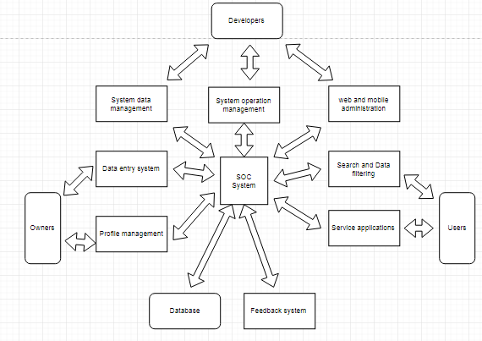

## Users

#### Owners

#### They’re the owners of the startups who have an OP.

#### Users

#### They’re our viewers of our website who have an UP.

## Developers

They are responsible for creating & designing the webpages, managing the system operations and contents.

## Modules

The system consists of following modules

## Storage

Exam cloud uses different types of storage:

* Core storage.
* System storage.
* Indexing storage.
* Analytics storage.

## Data analysis

Startups on the cloud holds huge amount of Startup Projects, information about them and their locations, user interaction and logs.

## Indexing

This module is responsible for indexing textual contents to allow internal part and full text search queries.

## Security

Security module is responsible for user authentication and communications security. User can register/login using internal accounts.

## Cloud Service

This module provides all system features through set of APIs. APIs are required by mobile applications and other software interfaces

## Customer Area

This module provides user with all tools required to reach his destination. User can create account; add likes, comments and feedback.

## Owners of Start Ups Area

This module provides the owner with main system activities like creating his own page, he/she can control it by writing description, uploading pictures or videos of the place & he/she can also update them, he/she can put their location so it helps the user to reach the destination faster.

* + 1. Supervisors Area

This module is dedicated for system operators. System operators are responsible for managing the system operation and contents.

## General mobile Application

Mobile application provides most of the web based system features using Mobile graphical user interface. Mobile applications are offered to normal users like Customers & Startups Owners.

## 

## START UPS Authority area

Users with permission (Owners) can edit the information, Update offers and view promo codes.

## System Administration Area

This module is dedicated for system administrators. System administrators are responsible for system management, configuration, backup and solving technical issues.

# System Users

## Developers

They are responsible for creating & designing the webpages, managing the system operations and contents. If the website user faces a problem & reports a place for example, we directly send him/her an email with a form containing some questions which are the place name, the issue, when did this problem happened , was it the first time, what could the place do to compensate you? , and any other comment, this helps us a lot, because if a certain place got a certain number of reports, we as the supervisors send him an email and warn him/her, and if they don’t take an action, we delete the project from the website after giving him/her enough time to do something.

## Owners

The owner of the startup can create his own page, he/she can control it by writing description, uploading pictures or videos of the place & he/she can also update them, he/she can put their location so it helps the user to reach the destination faster. One of the important features he/she has is replying to the customers and communicating with them. But his/her account has some different features than the user, he/she can’t search for any other page using this account, they have to make another account as a user, because the user is the one who can do that.

## Customers

Customer can create account, search for a nearby start-up (for example: co- working space, café or restaurant), add likes, comments and feedback. Customer can use the report button to announce for a problem so we send him an email containing a form to tell us his issue. The owner will be informed if the reports about a problem exceed a certain number, in order to reach the customer’s satisfaction and trust. There is also ‘contact’ us form if the user faces any problem with the website, if he wants to leave a message or a comment and it also have a rating question concerning the website.

# System Modules

## Storage

Exam cloud uses different types of storage:

* Core storage for Startup information and user interaction.
* System storage for system configuration, users information and fresh logs.
* Indexing storage to support part and full text search engines.
* Analytics storage(s) to store the outcomes of data analytics module.

Core storage uses MYSQL database. SQL database is a Relational database. In an SQL database, data is stored in multiple tables instead of in a single row. The different tables are related or connected using a common field called the key that is common to one or more tables. Using SQL, the data from multiple tables can be combined to get the information that we need. If the library data in the above example is stored in a relational database, we could break up the long row of data into multiple tables. In a relational Database, System storage uses traditional structured database which provide better queries and data processing.

## Context Diagram

System storage

Analytical Storage

Core storage

Storage

Indexing storage

## Data analysis

Startups on the cloud holds huge amount of Startup Projects, information about them and their locations, user interaction and logs. This module is important to study the projects carefully (Description and location). Basically this module support following data analytics. This analysis is important to avoid non useful Projects and incorrect data (like: location of startups, user accounts). Quality analysis to study the importance of the Startups based on user interaction. Statistical analysis to produce a set of statistical studies regarding Startups Projects and users interaction. It can study user satisfaction based on reviews, Rating, interaction with website and contribution to the system.

## Context diagram

Quality analysis

Data analysis system

Statistical analysis

## Indexing

This module is responsible for indexing textual contents to allow internal part and full text search queries. Full text and sub-part text search is used by final users to find certain contents. Also, it used by other modules like data processing to locate contents in a fixed time regardless the overall contents size.

## Security

Security module is responsible for user authentication and communications security. User can register/login using internal accounts. The portal access is made using https protocol in order to secure the communication. Security module is also responsible for managing the permissions and roles.

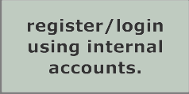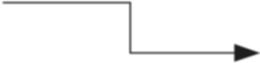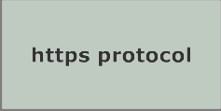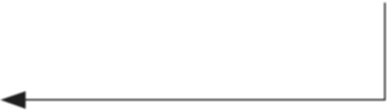

## Cloud Service

This module provides all system features through set of APIs. APIs are required by mobile applications and other software interfaces. External developers with permissions can use those APIs to build additional applications with different flavors. Exam Cloud encourages developers to build dependent software systems. Developers may build software applications for Mobile, Web and Desktop.

## Customer Area

This module provides user with all tools required to reach his destination. User can create account, add likes, comments and feedback. User can use the report button to announce for a problem so we send him an email containing a form to tell us his

issue. The owner will be informed if the reports about a problem exceed a certain number, in order to reach the user’s satisfaction and trust. There is also ‘contact’ us form if the user faces any problem with the website, if he wants to leave a message or a comment and it also have a rating question concerning the website.

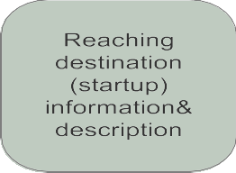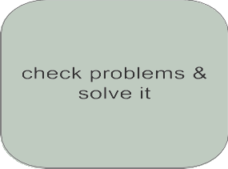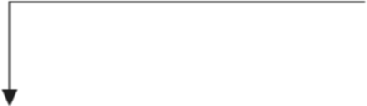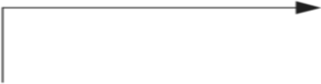

### Data flow diagram

## Owners of startups area

This module provides the owner with main system activities like creating his own page, he/she can control it by writing description, uploading pictures or videos of the place & he/she can also update them, he/she can put their location so it helps the user to reach the destination faster. One of the important features he/she has, which is replying to the customers and communicating with them. But

his/her account has some different features than the user, he/she can’t search for any other page using this account, They have to make another account as a user, Because the user is the one who can do that.

## Data flow diagram

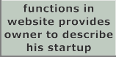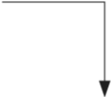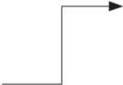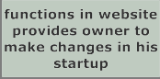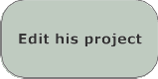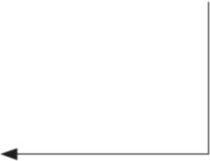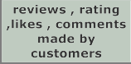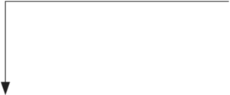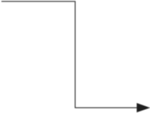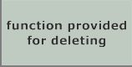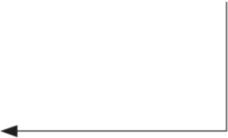

## Supervisors area

This module is dedicated for system operators. System operators are responsible for managing the system operation and contents. System operators, can access all system contents, the report button which the user clicks, when he/she faces a problem, we directly send him/her an email with a form containing some questions which are the place name, the issue, when did this problem happened , was it the first time, what could the place do to compensate you? , and any other comment, this helps us a lot, because if a certain place got a certain number of reports, we as the supervisors send him an email and warn him/her, and if they don’t take an action, we delete them after giving him/her enough time to do something.

## Data flow diagram

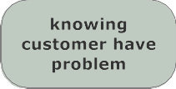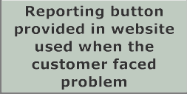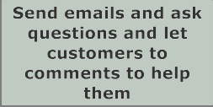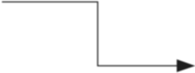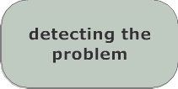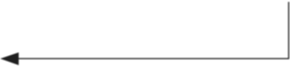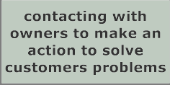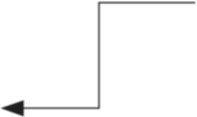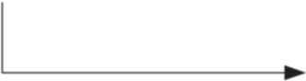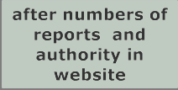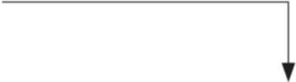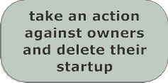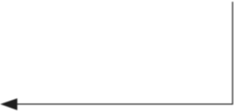

## General mobile Application

Mobile application provides most of the web based system features using Mobile graphical user interface. Mobile applications are offered to normal users like Customers & Startups Owners. Activities like administration, supervision, and authority management are supported only by the web based system. Mobile applications support major mobile platforms like Android, Windows-Mobile and IOS.

## START UPS Authority area

Users with permission (Owners) can edit the information, Update offers and view promo codes.

## Data flow diagram

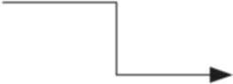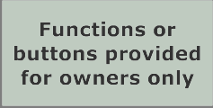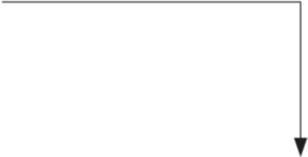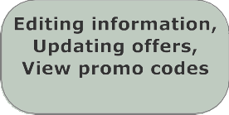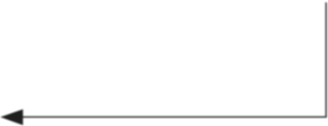

## System Administration Area

This module is dedicated for system administrators. System administrators are responsible for system management, configuration, backup and solving technical issues. System administrator can view system status, data status, logs and other system status and measures.

# System Functions

## Create accounts

-Description: SOC allows you to create account for both our customers and the startup owners. At the start page, user should decide whether to enroll as a customer or a startup owner. SOC offers two different forms for each kind of user.

-Inputs: Customers should provide their name, e-mail, phone number and city. Startup owners should provide the startup’s name, kind of service, e-mail, location in details (Format: building number, street, district), Google maps link, working hours and images.

* Output: The page as a user or owner according to the input information.
* Pre-condition: entering a valid data.
* Post-condition: database is established with a record for the user.

## Give feedback

-Description: It’s common that customers skip feedbacks, SOC solves this problem by offering a new method which is “pros and cons”. Also user can give an overall rating.

-Inputs: Customers can choose from default checkboxes statements to cover overall startup services as:

* Service ▪ Prices ▪ Quality ▪ Time Management

-Output: the rating

## Startup page

-Description: The Startup page contains information about the startup.

-Input: its name, service category, hotline, location in details, Google maps link, working hours and images. Users also can reserve slots through the startup page, get membership offers (loyalty membership) and discounts (promo codes).

Moreover, the owner can check the reviews of the customers. Having pros and cons helps to provide better services.

They can recommend startups. The number of recommends hits will be displayed on the page. Ones with highest recommendation numbers will be shown at the top of the search result. And because startup can be good, very good or excellent, recommend won’t be enough to describe the excellence of a startup rather than another one. SOC provides cloud rating.

-Output: all the information you will need concerning the topic of the page

-Pre-condition: every and each information that can be included in order to help the user and make it easy for him/her, entering a valid data.

* Post-condition: database is established with a record for the owner.

## Filter startups

-Description: SOC offers categories for users to choose from, after the user choose his/her district, the results will be filtered

-Input: choosing the wanted district.

-Output: After that the users should choose the district they want, and the results shown to the users will be filtered according to their choices and preferences.

-Pre-condition: Entering the wanted destination and the preferred places in order to be recommended to him/her.

## Place of the day

-Description: The website displays a place that is highly rated as the place of the day. This place changes daily and another place with high ratings gets the title and replaces the previous one.

-Input: just logging in to the website as a user.

-Output: place of the day will show up.

-Pre-condition: must be logged in to be able to see it.

## Set promo codes

-Description: This allows the owner to set the number of promo codes per day, and the customer can get one once he visits our website and the promo code is available.

-Input: setting the number of promo code.

-Output: getting the discount.

-Pre-condition: visiting our website.

## Loyalty membership

-Description: SOC provides a special service for long term frequent visits for a startup. The owner can set custom privileges of loyalty membership so a customer gets discounts.

-Input: visiting the website frequently

-Output: getting discount

-Pre-condition: visiting the website frequently.

## Give a feedback

-Description: SOC provides a textbox for users to express their opinions about the places or the events they attend. Users’ recommendations will help a lot. There is also a report button to allow users to explain a problem if needed

-input: the customer writes his opinion or pressing the report button.

-Output: helps in the recommendation and solving the problem.

# System Models

## Use Case Diagrams

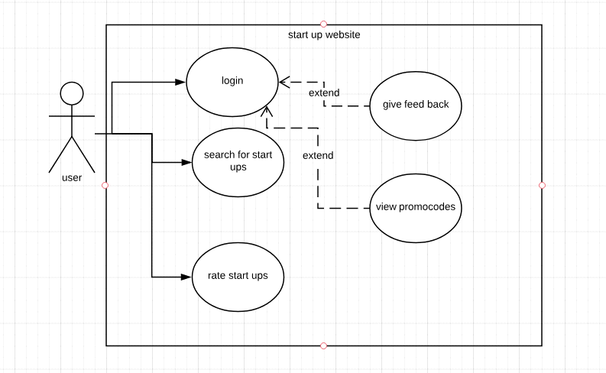

-This use case diagram shows the relation between the users of the website and the function he could do on the website, he could login to a personal account which gives him the authority to do many features such as feedbacking service and view promo codes to get discount from service owners for using our website.

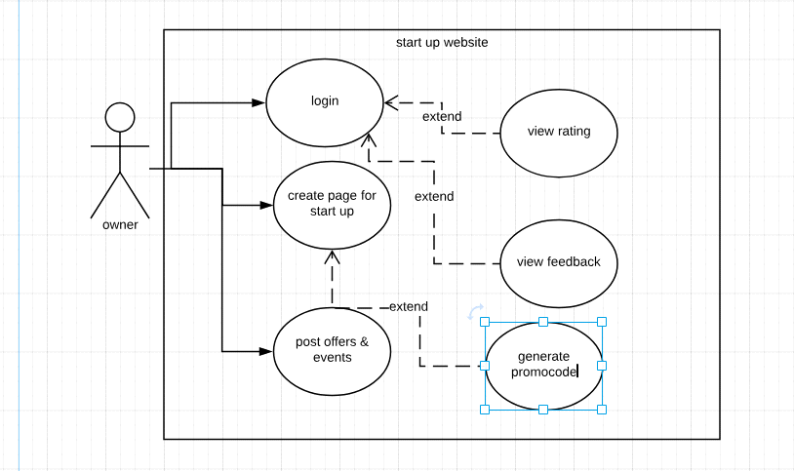

-This use case describe the relation between the owner of startups and the function they could do on it such as creating page for marketing their startups and view the ratings of customer and benefit from their feedbacks to avoid mistakes and give a better service, they could also post about events and offers for customer.

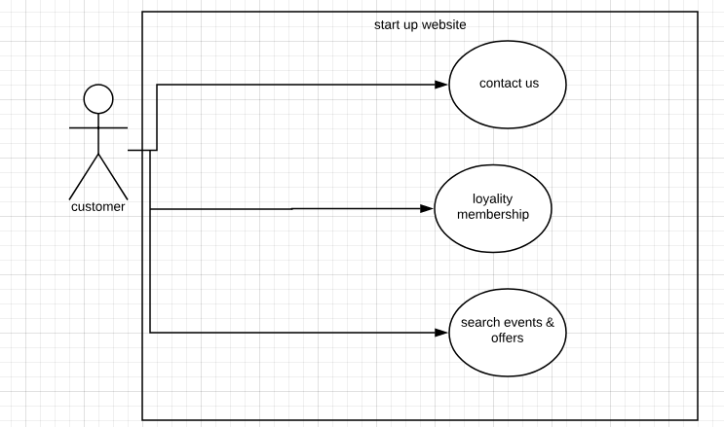

-This use case diagram shows the relation between the users of the website and the function he could do on the web site ,he could contact us for any problems and we will follow up with him ,he also has a loyalty membership which give him advantages for using web site, finally he could search events and offers occurring soon.

## Sequence Diagrams

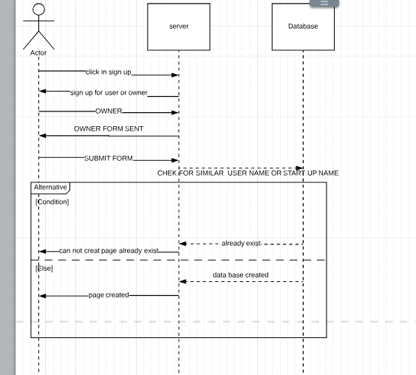

-This sequence diagram is used to show up a certain process function when owner asks to create a page on our website the server should check in the data base that the entered user name and start up name doesn't exist to avoid repeating and problems later and if it is ok the page will be created successfully if not error message will pop for invalid information

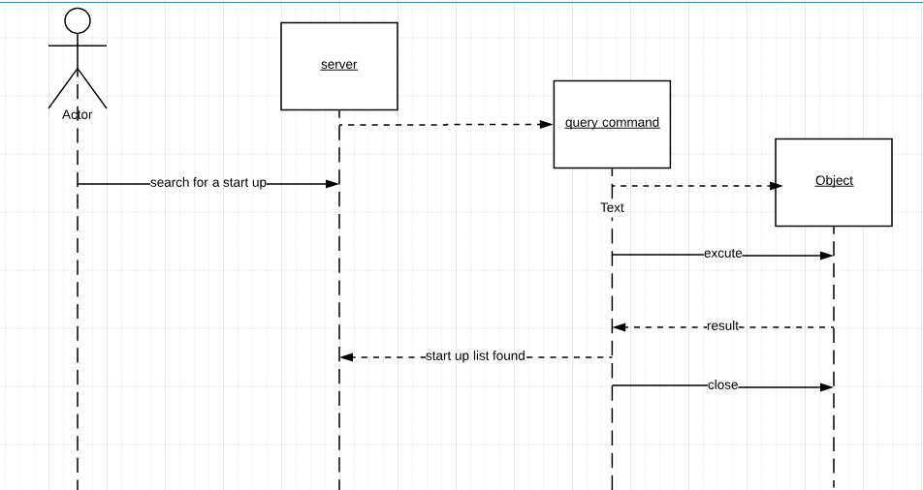

-This sequence diagram describe one of the basic functions on our website which is searching engine for startups as the user enter the service name a query connecting all the entered information is sent to the database which give back all nearby results to the user and sent back to him to choose the best for him

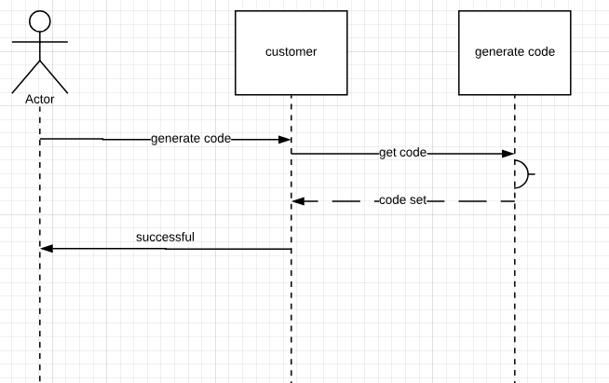

-This sequence diagram is used to show up a certain process function when customer asks to generate a promo code the class customer activate class generate code and ask it to generate a code and give it back

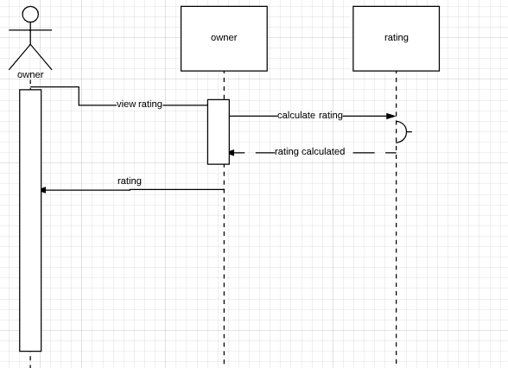

-This sequence diagram describe a process made by owners which is viewing their ratings up, the class owner give a calculate order for class rating which calculate the rating and give it back

# 

# Non-Functional Requirements

## Security

The website must be secure to insure the privacy of each user and to protect the user's accounts and information. This is achieved by using a proper login system as the user is requested to enter their own distinct usernames and passwords to avoid hacking.

## Usability

The website must be user friendly to facilitate user's interactions and usage of the website. The users will be able to use this website easily and effectively

## Performance

There will be a continuous interaction between the users and the website to ensure high quality performance and to make sure that each user enjoys an excellent experience and reaches the most relevant information to his request in a short time. The response of the system is fast.

## Development

The website is written using agile process.

# Domain Requirements

## Market Requirements

Feedback and reviews are required to let owners cope with customer desires.

# System Interfaces

## User Interfaces

* The users in our website are classified into:
* Owners of the startups
* Customers
  + - The Owner will be able to
    - See all the categories (co-working spaces, cafés, and restaurants), so he can choose any of them.
    - Sign up to the website.
    - Login to the website where he can get the available promo codes.
    - Get in contact to the website owners in ‘contact us’ page.
    - Add, edit or delete his project.
    - Add a detailed description of his project (images, location, menus, offers…etc).
    - See the reviews of his project.
    - Set the number of available promo codes per day.
    - Get notified by taken promo codes.
    - The Customer will be able to
* See all the categories (co-working spaces, cafés, and restaurants), so he can choose any of them.
* See the reviews of certain projects.
* Sign up to the website.
* Login to the website where he can get the available promo codes.
* See the description of each project.
* Get in contact to the website owners in ‘contact us’ page.
* Report certain projects if any issue happen.
* See the description of the website in ’About’ page
  + - Examples on Interfaces
* Sign up form

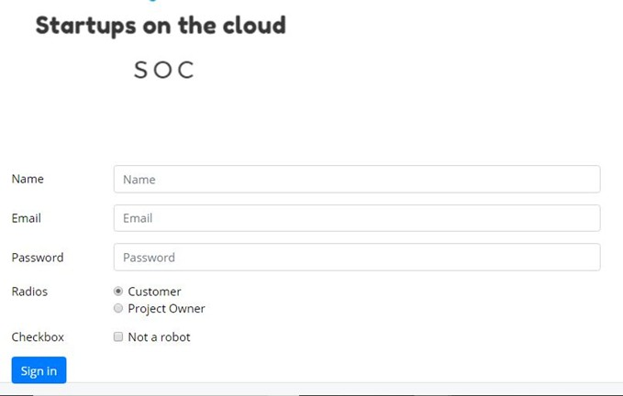

* Login form

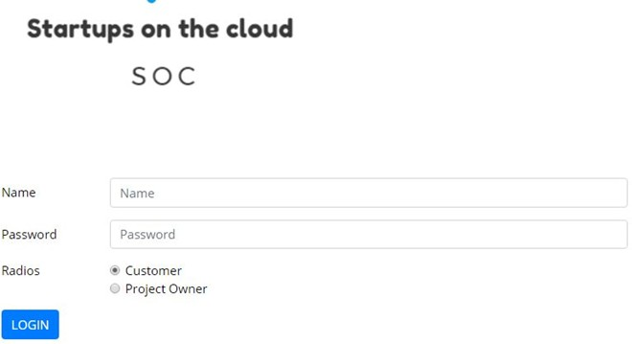

* Certain Category page

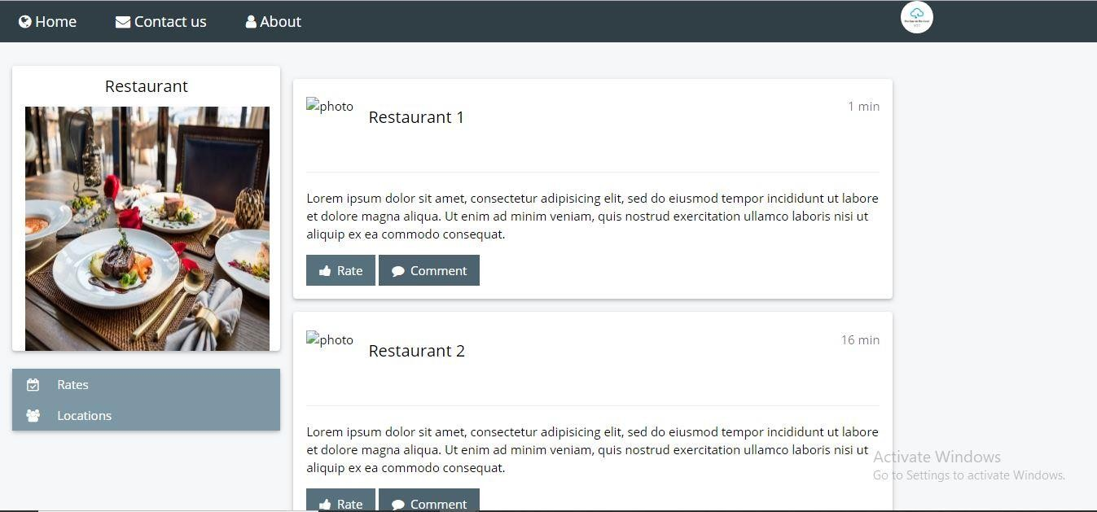

* 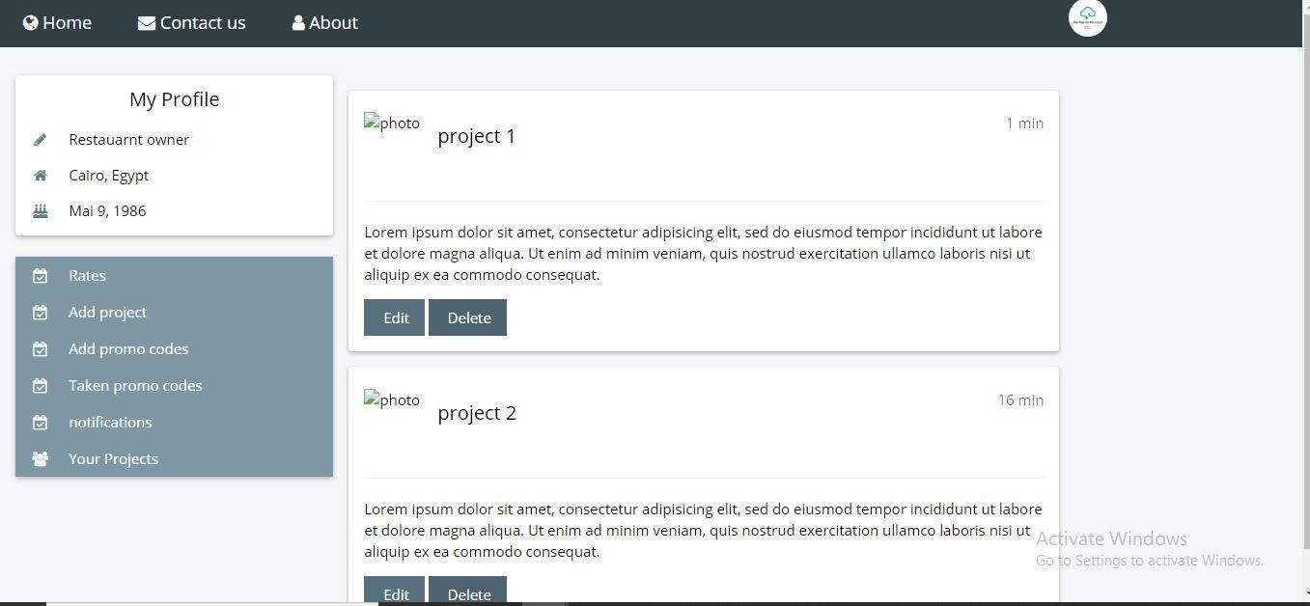Project Owner page
* Contact us

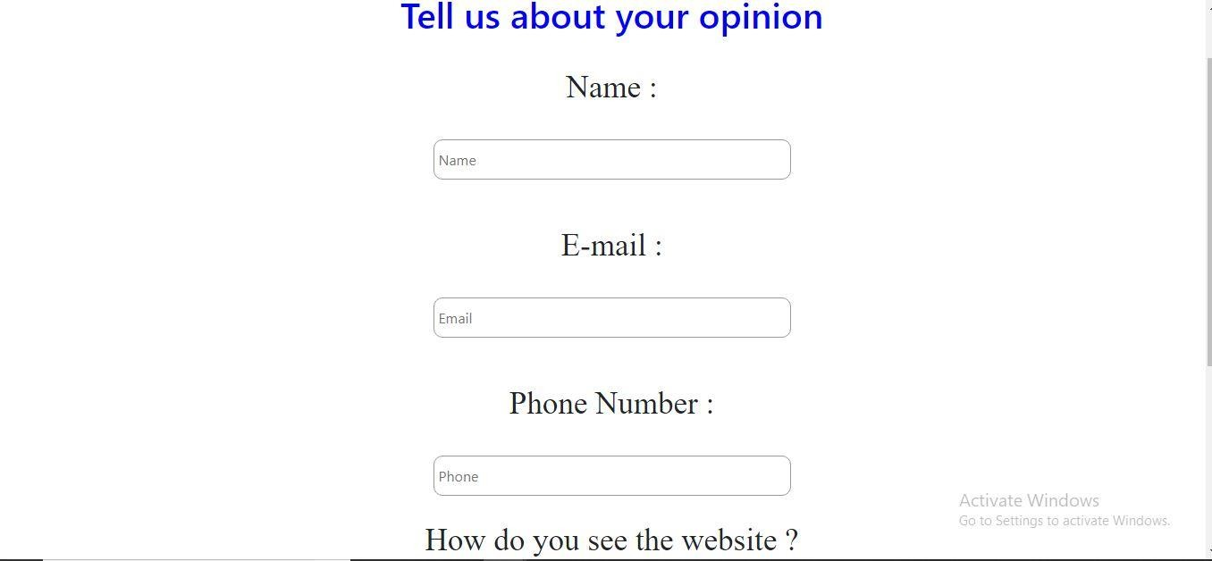

## 

## Hardware interfaces

**       **There is no hardware interfaces